Unit E Review Sheet

Invasive/Introduced Species
The main reason some _________________________ species survive and overpopulate an area is that there are often no natural predators in the area.

Food Webs/Chains

The role of _____________________ in an ecosystem is to convert the sun’s energy into energy stored as food.

A food web shows the flow of _________________through an ecosystem.

A scientist who studies populations in an ecosystem is called an _________________________.

The original source of energy for a producer is the __________ .

Producers are always __________________ .

An _____________________ refers to living organisms and the physical environment in which they live.

Feeding/energy flow relationships in ecosystems are best represented by ___________ __________.

__________________________ break down dead and waste matter.

The original source of energy for all organisms in a food web is _________________________ .

________________ is the study of relationships between living organisms and the environment.

Environment factors that are non-living are called _____________, whilst living factors are ___________.

Plants and Photosynthesis
The requirements for photosynthesis to occur are ____________________, _____________________,

and __________________________ .

Three causes for accelerated climate change and some solutions:

- _______________________________________________________________________

- _______________________________________________________________________

- _______________________________________________________________________

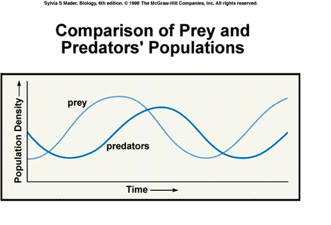
Explain why predator population lags (behind) the population of their prey

Draw a food web and label all organisms, also identify organisms as producers or consumers and their tropic level.

