Name:___________________________________________________________period____
Claim Evidence Reasoning
Base your answers on the data presented in the graphs.
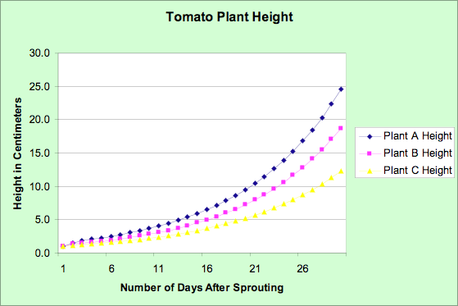
- What is the independent variable in this experiment?______________________________
- What is the dependent variable in this experiment?_______________________________
- What conclusion can be reached based on this data? Answer in CER format.
_______________________________________________________________________________________________________________________________________________________________________________________________________________________________________________________________________________________________________________________________________________________________________________________________________________________________________________________________________________________________________________________________________________________________________________________________________________________________________________________________________________________________________________________________________________________________________________________________________________________________________________________________________________________________________________________________________________________________________
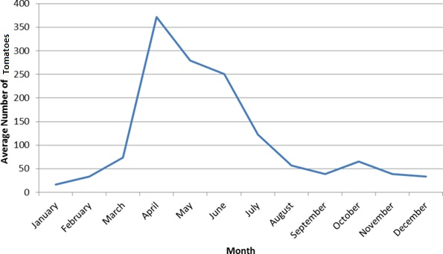

- What is the independent variable?________________________________________________
- What is the dependent variable?_________________________________________________
- Which season is the most productive tomato growing season? Answer in CER format ________________________________________________________________________________________________________________________________________________________________________________________________________________________________________________________________________________________________________________________________________________________________________________________________________________________________________________________________________________________________________________________________________________________________________________________________________________________________________________________________________________________________________________________________________________________________________________________________________________________________________________________________________________________________________________________________________________________________________________________________________________________

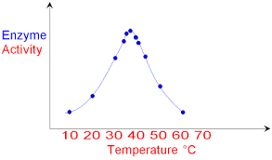
Enzymes are proteins that regulate chemical activities in the body. Based on the graph above answer questions 7-9.
- What variable did the researcher change?__________________________________________
- What variable did the researcher think would be affected by that change?__________________
- What is the relationship between Temperature and Enzyme Activity? Answer in CER format. ____________________________________________________________________________________________________________________________________________________________________________________________________________________________________________________________________________________________________________________________________________________________________________________________________________________________________________________________________________________________________________________________________________________________________________________________________________________________________________________________________________________________________________________________________________________________________________________________________________________________________________________
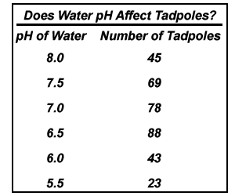Using the table to the left complete the graph below and Q. 10.
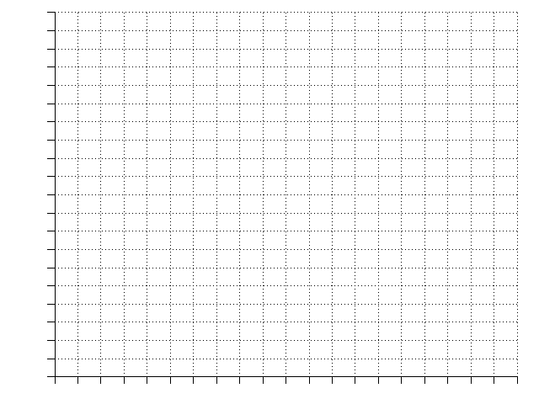

- Describe the relationship of Water pH (acidity) and Tadpole Population using CER.
________________________________________________________________________________________________________________________________________________________________________________________________________________________________________________________________________________________________________________________________________________________________________________________________________________________________________________________________________________________________________________________________________________________________________________________________________________________________________________________________________________________________________________________________________________________________________________________________________________________________________________________________________________________________________________________________________________________________________________________________________________________

